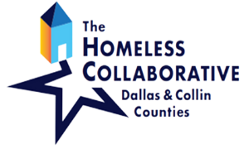

Case Managers Roundtable 2022

What: Network and participate in professional development beneficial to your work.

When: Fourth Wednesday of the month, 12-1.30pm (Nov. and Dec. combined)

January 26
February 23
March 23
April 27
May 25
June 22
July 27
August 24
September 28
October 26
November 30

Please contact Trudy Hernandez (Trudy.Hernandez@mdhadallas.org) for access to the virtual meeting link.

