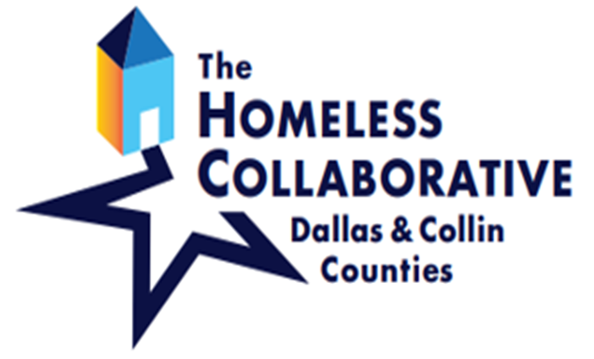
logo

Board of Directors Meeting
Zoom
October 7, 2021
2:00pm - 4:00pm
AGENDA

- Welcome | Ashley Brundage,  Chair of The Homeless Collaborative
- Consent Agenda  - Electronic Resolution approval  *Voting Items | Ashley Brundage,  Chair of The Homeless Collaborative
- Homeless Collaborative Updates | Ashley Brundage,  Chair of The Homeless Collaborative, MDHA
- MDHA Updates | Joli Angel Robinson, President and CEO, MDHA
- HUD NOFA Overview & Process | Sarah Kahn, Chief Program Officer, MDHA
- Policy Approval  *Voting Items | Tammy McGhee, Clutch Consulting
- CoC Assembly Executive Council Report | Dr. David Woody, Chair of Executive Council
- Public Comments – 10 Minutes (Remarks will be limited to 3 minutes. Time may be extended at the discretion of the Chair.) | Please email Makyia Caraway at Makyia.caraway@mdhadallas.org to make a public comment.
- Adjournment | Ashley Brundage,  Chair of The Homeless Collaborative

