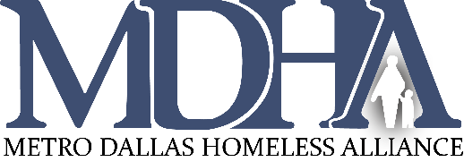
CoC Values:
Teamwork
Transparency
Tenacity

Our CoC exists to end homelessness in Dallas and Collin Counties through a collaborative and strategic effort which optimizes the combined strengths and resources of our partnering organizations and the neighbors we serve.

Dallas City & County/Irving Continuum of Care Assembly
February 23, 2021 9:00 a.m.
Virtual Meeting-Webex

- Welcome & Introductions Dr. David Woody, CoC Assembly Chair
- Mission Moment Ashley Brundage, CoC Board Chair &
Senior Vice President, United Way
- Approval of January 2021 Minutes Dr. Woody
Networking Opportunity

- CoC Board Updates Ashley Brundage
- CoC Work Group Updates Shavon Moore
Vice President of Programs, MDHA
- ESG Consultation Follow Up Kevin Oden
Office of Homeless Solutions Interim Director

- Announcements (See MDHA website calendar for login info for public meetings.)
  - Case Manager Round Table - Wednesday, February 25, 2021, noon until 1:30 p.m. Topic: Move On Project & Flex Fund
  - CAS Information Meeting, What’s Happening with CAS, Wednesday, February 24, 2021 9:00 a.m.
  - ESG CV II Orientation for New Rapid Rehousing Providers, Thursday, February 25, 2021 1:30 p.m.
  - Save the Date for the 7th annual State of Homelessness Address – Tuesday, May 11, 2021, 9:30-11:30 a.m.
- Adjournment
For comments or questions regarding Continuum of Care Assembly business, please contact Chair Dr. David Woody at dwoody@bridgenorthtexas.org or Vice-Chair Brenda Snitzer at BrendaS@thestewpot.org

