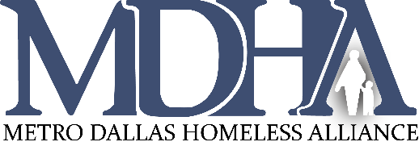
CoC Values:
Teamwork
Transparency
Tenacity

Our CoC exists to end homelessness in Dallas and Collin Counties through a collaborative and strategic effort which optimizes the combined strengths and resources of our partnering organizations and the neighbors we serve.

Dallas City & County/Irving Continuum of Care Assembly
January 26, 2021 9:00 a.m.
Virtual Meeting-Webex

- Welcome & Introductions Dustin Perkins, CoC Assembly Chair
- Mission Moment Tammy McGhee, Director of System
Transformation, Clutch Consulting
- Elections-CoC Executive Council Dustin Perkins, CoC Assembly Chair
Networking Opportunity
- Approval of December 2020 Minutes Dustin Perkins
- CoC Board Updates Dustin Perkins
- ESG Consultation Kevin Oden
Office of Homeless Solutions Interim Director
- Announcements
  - Results of the CoC Executive Council Elections
  - CoC General Assembly 2021 Dates and Login Info – also on the MDHA website calendar
  - Case Managers Roundtable 2021 Dates and Login Info – also on the MDHA website calendar
  - January 27, 2021, 12-1.30pm – Case Managers Roundtable – RoommateMe – George Farhat will present about how RoommateMe supports renters in reducing the cost of housing and optimizing cohabitation living environments.
  - Newsletter submissions due – CoC Assembly Newsletter – February 9, 2021, Homeless Response System Newsletter – February 23, 2021 – email david.gruber@mdhadallas.org
  - February 18, 2021 – 2021 COVID 19 PIT Homeless Count Kickoff – Stay tuned!
  - 2021 COVID 19 PIT Homeless Count – February 18-March 3, 2021 – Conducted by street outreach teams ONLY
  - For your convenience, we have created a CoC General Assembly Agendas and Minutes page on the MDHA website, where we will post all info you need for these meetings from now on!
- Adjournment
For comments or questions regarding Continuum of Care Assembly business, please contact Chair Dustin Perkins at Dustin.Perkins@austinstreet.org or Vice-Chair Dr. David Woody at dwoody@bridgenorthtexas.org

