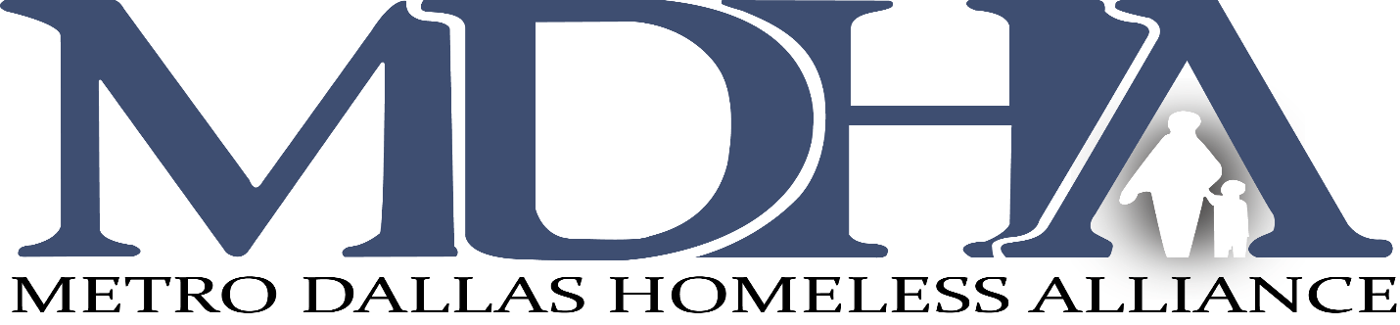

Board of Directors Meeting
Friday, May 15, 2020 9am | 2 hours

MINUTES
Attendees: Karen Hughes, Dustin Perkins, Edd Eason, Traswell Livingston III, Isabel Camacho, Brooke Etie, Rick Grady, Christine Ortega, Jeffrey Zsohar, Ellen Magnis, Deliza Gierling, Kevin Odom, Regina Levine, Lane Connor, Daniel Roby, Ikenna Mogbo, Michael Walker, Erin Moore, Dr. David Woody, David Noguera, Jessica Galleshaw, Victoria Tsaliksis. Staff: Carl Falconer, Shavon Moore, Alexandria Espinosa, Freda Nelms, Phil Force, David Gruber and Diana Romagnoli.

Welcome and Roll Call by Karen Hughes. Carl gave a recap of the virtual meeting protocol including those attending by phone.

Minutes of the Meeting April 10, 2020 with a motion to approve from Ellen Magnis and second by Dustin Perkins. All approved.

CoC COVID-19 updates were presented by Carl Falconer.
- The Heroes Act was explained with funding targeted to$1B in new vouchers to Public Housing Authorities for homeless individuals
  - $11.5B in Emergency Solutions Grant Funding
  - $100B in eviction prevention funding
  - 2020 Housing and Urban Development Notice of Funding Availability Competition cancelled and each CoC would receive what they got in 2019 NOFA process
- ESG funding released by TDHCA to State communities is anticipated to be distributed in July 2020. MDHA has submitted an application to be the CoC Coordinator for the Application Process. A decision on that request will happen by May 23, 2020
- ESG funding released by the City of Dallas (Kevin Odom spoke) is being reviewed by the City Council and the application process should open the last week of May 2020 to the community.
- MDHA staff is phasing in the return to the office during the month of May.

CoC Assembly updates were presented by Dustin Perkins.
- Committee Leaders meeting is scheduled for May 19th. Stephanie Harris is joining the Committee structure as the Chair of the Education and Employment Committee. They will begin meeting in June 2020
- CoC performance survey was discussed. Dustin would like to prepare for it now. It is normally completed by the CoC in September or October annually.
- D-One deliverables.
- CoC Assembly Meeting is scheduled for Tuesday May 26th, virtually.

Committee Reports
Executive Committee: Karen Hughes, chair, stated that the Committee has been meeting virtually each month reviewing on-going MDHA/CoC activities.
Nominating Committee: Traswell Livingston stated that the Committee meets on the second Tuesday of the month. Traswell asked that all Board members please complete the Commitment Forms distributed recently. He expanded on the reason for the form. He also mentioned that during the months of June and July 2020 that vice chair, Jessica Galleshaw, will handle the business of the Committee. The Board currently has 25 active members. The Committee is bringing to the Board today Kevin Odom, Director of OHS (who will replace the position vacated by Monica Hardman) and Christina Mintner, Parkland Homes Program.

The Board unanimously accepted the two proposed Board members.

Finance Committee: Edd Eason, Chair, presented the finance report to the Board. He mentioned that the March financials were presented at the May 7th meeting. It was noted that there was a low cash position. This was due to reconciliation on the HMIS grant. The staff was revisiting the last three months and wanted that complete before a draw occurred. Edd mentioned that MDHA received the PPP and EIDL funds in early May. Additionally, the Committee has outlined a monitoring plan for agencies in the CoC that are behind on spending down their HUD funds. Contact will be made before the end of May 2020. Traswell asked for clarification on the draw down when there are barrier and issues. Edd asked that all agencies address those concerns in their response to the Committee. Finally, the MDHA single audit field visit will begin May 18th for the week.

HMIS Committee: David Noguera, Chair, presented a slide of the recent actions by the Committee. The four workgroups are actively engaged in their topic of focus: Systems Oversight (Eccovia Solutions), Monitoring and Compliance (HMIS Lead Agency), Data Management (data quality) and Strategic Planning (D-One & Coordinated Entry). They are early in their work, but I believe there will be good impact by what they stay on top of with the CoC and HMIS users. The HMIS implementation timeline is has pushed back the Coordinated Entry completion date to July 1st and after that is complete there will be a period on the timeline to work on customizations for the system. Austin Street Center and The Bridge are working with Eccovia Solutions to have their data added to the ClientTrack software HMIS. There is no date when that is anticipated to be complete.

CEO/President’s Report

- Carl began by providing a debriefing of the Summary of the Continuum of Care.
- There is a bill before Congress which has included in it the passing of this year’s NOFA cycle. The details are not available but in the next few weeks if this bill isn’t altered there will be notification from HUD.
- The D-One Plan Meeting was cancelled in March due to new COVID-19 activities. During April Chad West resigned as co-chair of the Committee. Carl and Kenn Webb are scheduled to meet and discuss a new co-chair and the current state of the D-One Plan.
- C-One Plan. Collin County is in its early stages of work on their plan. Co-chairs Rick Grady and Suzanne Smith were voted on by the large group. They have a small group meeting weekly to set out the plan for Collin County and then will convene the large group for an open discussion.
- Clutch Consulting, a strategic planning group, has begun work with MDHA in support of the CoC through data management. They will be in Dallas for meetings May 18th and 19th.

Karen closed the meeting. The next meeting will be July 17th.

Adjourned at 10:30am.

- Welcome/Introduction | Karen Hughes
- Approval of Meeting Minutes of April 10, 2020  - COVID-19 CoC Update | Karen Hughes  Carl Falconer & Board
- CoC Assembly Updates | Dustin Perkins
- Committee Reports  - Executive Committee  - Nominating Committee  - Finance Committee  - HMIS Committee | Karen Hughes  Traswell Livingston  Edd Eason  David Noguera | Action Items  New Members: Christina Mintner, Parkland  Kevin Oden, City of Dallas
- President/CEO Report | Carl Falconer
- CoC Debriefing Summary

