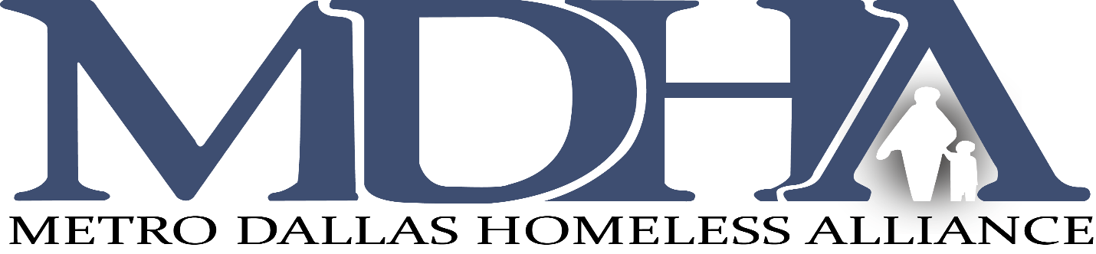

Board of Directors Meeting
Friday, July 17, 2020 10am | 2 hours

AGENDA

- Welcome/Introduction | Karen Hughes
- Approval of Meeting Minutes of May 15, 2020, Special Meeting June 22, 2020, and July 10, 2020  - CoC Assembly Updates | Karen Hughes  Dustin Perkins
- Clutch Consulting | Tammy McGhee
- Committee Reports  - Executive Committee  - Nominating Committee  - Finance Committee  - HMIS Committee | Karen Hughes  Jessica Gallishaw  Edd Eason  David Noguera
- President/CEO Report | Carl Falconer
MDHA Staff Update
Ending Veteran Homelessness
ESG CARES Act update

