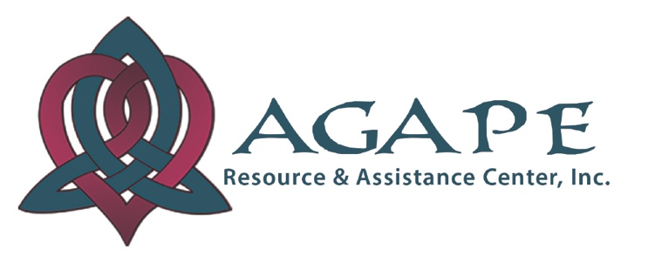

**P. O. Box 861664**

**Plano, TX 75086-1664**

**Phone: 469-814-0453**

**www.Hope4Agape.org**

**Info@Hope4Agape.com**

**AGAPE RESOURCE & ASSISTANCE CENTER, INC**

In 2013 Agape Resource & Assistance Center, Inc. was founded in 2013 by Rev. Janet Collinsworth to proactively address the increasing problem of homelessness in Collin County, in particular the impact on women and children. Agape is a unique, holistic, faith-based program serving homeless women led families by providing safe, stable housing & transformation services to single women, moms & their kids in crisis or living at or below the poverty level in Collin County & zip codes within 5 miles of Agape’s office in East Plano.

**PROBLEMS AGAPE SOLVES** - Agape provides life changing solutions to the growing problems of homelessness & poverty that debilitate thousands of single women, moms & their kids in our area. Affordable housing is effectively non-existent in Collin County. There are no emergency shelters. Although Collin County communities are viewed as affluent, there are only about 350 shelter & agency beds, all chronically full. On average, over 4,000 people are being turned away EACH YEAR from housing agencies; 75% are single women head of households, most with children 10 years & under. Extended stay hotels serve as “homes” on school bus routes. In the last 7 years, PISD children on free/reduced lunch has MORE THAN DOUBLED (32% /17,000 in 1.2020 vs 14% /10,000 in 2010). PISD children identified as homeless has increased over 4 times (>400 in 1.2020 vs 115 in 2009).

**WHAT AGAPE DOES** - While safe, stable housing is a critical need, Agape believes it is only the first step in a long, hard journey to self-sufficiency. In addition to safe, stable housing, Agape provides childcare & transportation assistance, vocational counseling and scholarships towards higher income jobs, job placement assistance, trauma based group and individual counseling and therapy for moms and kids, compassionate, accountability based casework and the ways and means to achieve a future with hope not defined or limited by their past

Agape’s H4H program holistically provides solutions to the major barriers to economic and emotional stability, NOT a Band-Aid by addressing one or two of the debilitating problems. As supported by the Texas Women’s Foundation 2017 study, “Economic Issues for Women in Texas”, women head of house families, particularly those that are homeless, low to moderate income & / or domestic violence survivors, run into the same four debilitating roadblocks: housing, healthcare, childcare and earning capacity. In Collin County, we add transportation as a debilitating barrier. Agape’s holistic 4-Pronged Approach is proven to help homeless women led families overcome primary barriers to economic and emotional stability.

**WHO AGAPE SERVES** – Over 80% of Agape’s families are victims of abuse & violence, some from human trafficking & all come without a support system to help them overcome the debilitating oppression of poverty & homelessness. Lasting transformation takes time, patience, compassion & faith: the cornerstones of the Agape program. 100% of Agape families are homeless & living at or below the poverty level when they enter our program. Agape helps low to moderate income families by providing the resources needed to become financially stable, breaking cycles of homelessness & poverty for generations to come. Agape requires women to have a job. Ave income at entry is $10/hr or $15K-$20K /yr, well below the poverty level. A primary goal of Agape is to empower women to achieve self-sustained living through workforce training & job placement & financial education & coaching. Agapeans graduate with the ability to afford stable housing, childcare, transportation, and make between $30K-$40K/year, most with benefits. The Housing 4 Hope program provides the ways & means for families to attain economic & emotional stability & enjoy self-sustaining futures not limited or defined by their pasts.

**PROVEN RESULTS** - In its 7 years Agape has grown from 2 beds & a crib to supporting 8 housing units with 45 beds. As of May 2020, Agape provided housing & hope for 161 unduplicated souls, including 66 women head of household families with 95 children. Agape has provided over 80,000 nights of shelter and had to turn away over 500 families in 2019 alone. Of the 66 families Agape has served, 40 women (71%) with 47 children have graduated with jobs that enable them to provide homes & stability for their children whose past experiences no longer define their future hopes.